Software Requirements Specification

for

Automated Detection of Diabetic Retinopathy Using Artificial Intelligence

Prepared by:

Afaq Mahmood: csd201018 Raja Shahzeb Sajid: csd201027 Aryan Hakeem: csd201011

Supervisor: Sir Dr. Mobin Idrees

DHA SUFFA UNIVERSITY

7F-DCK

Table of Contents

1. Introduction 3

1.1 Diabetic Retinopathy 3

1.2 IN FIGURE 1: 4

1.3 Symptoms 5

2. Four Stages of Diabetic Retinopathy 6

3. Diabetic retinopathy symptoms & overall workflow: 9

3.1 Pathological Changes: 9

3.2 Symptoms: 10

3.3 Workflow Structure. 11

4. Purpose 12

5. Project Scope 13

5.1 In Scope: 14

5.2 Out of Scope: 14

6. Overall Description 16

7. Project Functions 18

8. Image Pre-Processing of DR 19

9. Project Working 21

9.1 User Classes and Characteristics 23

9.2 Operating Environment 23

9.3 Design and Implementation Constraints 24

9.4 User Documentation 24

9.5 Assumptions and Dependencies 24

10. External Interface Requirements 25

10.1 User Interfaces 25

10.2 Communications Interfaces 26

11. System Features 26

11.1 Predictions of disease 26

11.2 Automated Screening 26

11.3 Continuous Learning and Improvement 27

11.4 Use Case Diagram 27

11.5 Class Diagram 28

12. Other Non-functional Requirements 29

12.1 Performance Requirements 29

12.2 Safety Requirements 29

12.3 Security Requirements 29

12.4 Software Quality Attributes 30

12.5 Usability Requirements: 30

13. References 30

13.1 Figure1: 30

13.2 Figure2: 30

13.3 Figure3: 31

13.4 Figure 4: 31

13.5 IEEE Xplore Digital Library 31

13.6 ACM Digital Library 31

13.7 ScienceDirect 31

# Introduction

This document serves a diverse audience, including healthcare professionals, technology developers, researchers, policymakers, and stakeholders. Healthcare professionals, such as ophthalmologists and general practitioners in Pakistan, can focus on practical applications and benefits of the AI algorithm in diabetic retinopathy detection, while technology developers may find value in technical specifications and integration details. Researchers can explore advanced AI techniques for feature extraction, and stakeholders can gain insights into the potential impact on healthcare systems. The development of an AI algorithm for diabetic retinopathy detection centers on the precise extraction of features from retinal images, meticulously crafted for seamless integration into the current healthcare systems. Thorough performance assessments against established benchmarks ascertain its effectiveness and potential to significantly enhance patient outcomes through timely intervention and treatment for diabetic retinopathy.

## Diabetic Retinopathy

Diabetic Retinopathy (DR) is a complication resulting from prolonged exposure to high blood glucose levels in diabetes, causing damage to the retina. This harm primarily affects small blood vessels, leading to abnormal vessel growth, fluid leakage, and the formation of scar tissue. As a consequence, severe vision impairment may occur. Hemorrhages, or bleeding in the back part of the eye, can result from the damaged blood vessels, further impacting vision. Timely detection and effective blood sugar management are critical in preventing irreversible vision loss associated with diabetic retinopathy. Regular eye check-ups are essential for monitoring and managing this condition.

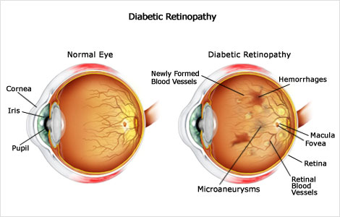

Figure 1: Diabetic Retinopathy [1]

## IN FIGURE 1:

In the left side of the figure, representing a normal human eye, the cornea, iris, and pupil appear clear and free from any defects. The overall structure of the eye is depicted as healthy, with transparent blood vessels. This normal eye indicates a typical, well-functioning visual system. On the right side of the figure, representing a human eye affected by diabetic retinopathy (DR), several abnormalities are evident. New blood vessels, depicted in brown shade, indicate abnormal vessel growth, a characteristic feature of DR. Hemorrhages, or bleeding, are visible, affecting the eye, and they are represented by the brown shading in the figure. These hemorrhages can occur due to the damage to small blood vessels in the retina.

Additionally, the macula and fovea, crucial areas responsible for central vision, are shown to be affected in the DR eye. This implies a potential impact on detailed and sharp vision. The retinal blood vessels exhibit abnormalities, including microaneurysms, which are small bulges in the blood vessels. Comparatively, the differences between the normal eye and the DR-affected eye highlight the consequences of diabetic retinopathy. While the normal eye maintains clear structures and healthy blood vessels, the DR-affected eye experiences abnormal blood vessel growth, bleeding, and damage to critical areas like the macula and fovea. These changes can lead to severe vision impairment and underline the importance of timely detection and effective management of blood sugar levels to prevent irreversible vision loss in individuals with diabetic retinopathy. Regular eye check-ups are crucial for monitoring these changes and implementing appropriate interventions.

## Symptoms

Diabetic Retinopathy (DR) presents a spectrum of symptoms that can significantly impact vision as the disease progresses. One common manifestation is the occurrence of floaters, which are perceived as spots, dots, or cobweb-like dark strings that seem to float within the visual field. These floaters can disrupt normal vision and become particularly noticeable. Additionally, individuals with DR may experience blurred vision, characterized by a noticeable decrease in sharpness and clarity. This blurring effect can compromise the ability to discern fine details and lead to a general reduction in visual acuity. Fluctuating vision, marked by periodic changes from blurry to clear vision, further underscores the dynamic nature of the condition.

Dark areas in the vision, described as blank or dark regions in the field of vision, are another distressing symptom. This can result in the perception of missing or obscured portions in one's sight. Poor night vision is also a common challenge, wherein individuals face difficulty seeing clearly in low-light conditions. This can significantly affect nighttime activities and may pose safety concerns.

Altered color perception is another noteworthy symptom of DR, where colors may appear washed out or different from the usual vibrant hues. This perceptual shift can contribute to a distorted visual experience. As the disease advances, one of the most concerning symptoms is vision loss, marked by a progressive decline in visual capabilities. It is crucial for individuals experiencing any of these symptoms, especially those with diabetes, to seek prompt medical attention. Regular eye examinations play a pivotal role in early detection, allowing for timely interventions and the preservation of vision.

# Four Stages of Diabetic Retinopathy

Diabetic retinopathy, an eye disease triggered by elevated blood sugar levels, unfolds through four progressive stages, each characterized by the deterioration of delicate blood vessels in the retina among individuals with diabetes.

This advancing eye ailment poses risks of blurred vision and, in severe instances, irreversible vision loss. Underscoring the importance of regular eye examinations becomes paramount, as noticeable symptoms may only emerge after vision loss has already taken place. Swift diagnosis by your eye doctor holds the key to promptly initiating measures aimed at slowing down the progression of diabetic retinopathy.

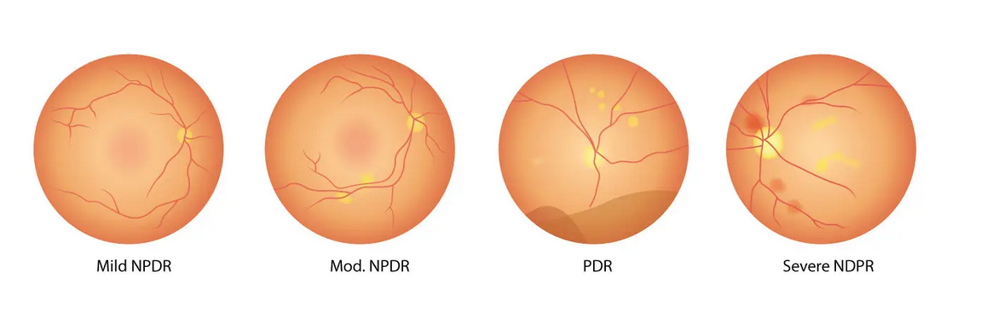

Figure 2: The 4 Stages of DR [2]

**Stage 1: Mild Non-proliferative Diabetic Retinopathy**

At this initial stage, the disease is characterized by the presence of microaneurysms—tiny swellings in the retinal blood vessels. Despite the development of these bulges, there are typically no noticeable symptoms. Microaneurysms may cause small amounts of fluid to leak into the retina, potentially leading to swelling of the macula, which is the back part of the retina. However, this stage usually progresses without clear indicators of a problem.

**Stage 2: Moderate Non-proliferative Diabetic Retinopathy**

In this stage, the tiny blood vessels in the retina continue to swell, impeding proper blood flow to the retina and hindering its nourishment. Notably, symptoms become apparent only if there is a buildup of blood and other fluids in the macula, causing a decline in vision sharpness and clarity.

**Stage 3: Severe Non-proliferative Diabetic Retinopathy**

At this critical stage, a larger section of retinal blood vessels becomes blocked, leading to a significant decrease in blood flow to the area. In response, the body initiates the growth of new and fragile blood vessels. This stage brings noticeable symptoms such as blurry vision, dark spots, and even patches of vision loss. If these new vessels leak into the macula, irreversible vision loss becomes a high risk.

**Stage 4: Proliferative Diabetic Retinopathy**

Representing an advanced stage, proliferative diabetic retinopathy is characterized by the continued growth of thin and weak blood vessels in the retina. These vessels are prone to bleeding, causing scar tissue formation inside the eye. The scar tissue can pull the retina away, leading to retinal detachment. Symptoms include blurriness, reduced field of vision, and, in severe cases, permanent blindness. This stage emphasizes the urgent need for intervention to prevent irreversible vision loss. Regular eye examinations are essential for monitoring and addressing diabetic retinopathy at its various stages.

# Diabetic retinopathy symptoms & overall workflow:

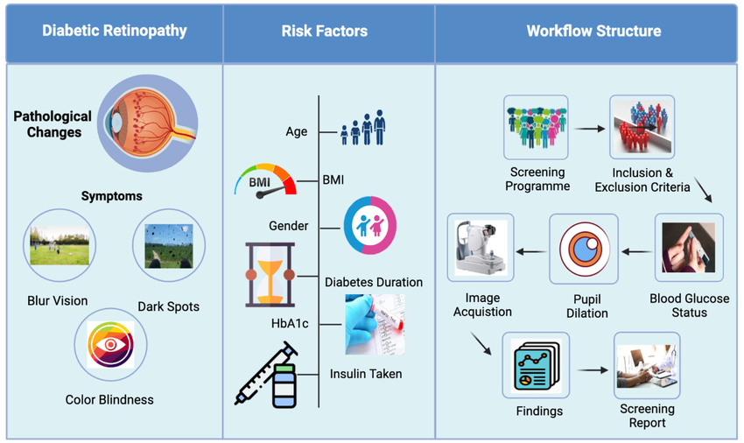

Figure 3: Illustration of diabetic retinopathy symptoms & overall workflow [3]

## Pathological Changes:

* When diabetic retinopathy is present, there are several pathological changes that occur in the eye due to damage to the blood vessels in the retina.
* The retinal blood vessels may become leaky or blocked, leading to reduced blood flow and oxygen delivery to the retina.
* As a result, abnormal new blood vessels may grow on the surface of the retina, which can lead to bleeding, scarring, and eventually vision loss if not treated.

## Symptoms:

1. **Blurry Vision:** Blurry vision refers to a visual impairment characterized by a lack of sharpness and clarity in eyesight. In the context of Diabetic Retinopathy, this symptom can occur as a result of damage to the blood vessels in the retina, leading to fluid leakage and affecting the ability of the eye to focus properly.
2. **Dark Spots:** Dark spots are areas within the field of vision that appear darker than the surrounding areas. In the context of Diabetic Retinopathy, these spots may result from bleeding or the presence of abnormal blood vessels in the retina. Dark spots can interfere with normal vision and contribute to visual disturbances.\
3. **Color Blindness:** Color blindness refers to a condition where individuals have difficulty distinguishing between certain colors. In the context of Diabetic Retinopathy, color blindness may occur due to damage to the photoreceptor cells in the retina responsible for color perception. This can lead to a distorted or washed-out appearance of colors in the affected person's vision.

## Workflow Structure.

1. **Screening Programmed:** The process begins with the establishment of a screening program designed to identify individuals at risk of diabetic retinopathy. This program aims to reach a target population, often individuals with diabetes, to assess their eye health and detect signs of diabetic retinopathy early on.
2. **Inclusion & Exclusion Criteria:** In this stage, specific criteria are defined to determine who is eligible (inclusion criteria) and who should be excluded (exclusion criteria) from the screening program. Inclusion criteria may involve individuals with diabetes, while exclusion criteria could consider factors like pre-existing eye conditions or other medical issues that may affect the screening results.
3. **Blood Glucose Status:** Assessing the blood glucose status of individuals is crucial in the context of diabetic retinopathy screening. Elevated blood sugar levels are a risk factor for the development and progression of diabetic retinopathy. This step ensures that individuals with diabetes are appropriately identified and included in the screening process.
4. **Pupil Dilation:** Pupil dilation is a standard procedure in diabetic retinopathy screening. Dilating the pupils allows for a better view of the retina, enabling healthcare professionals to thoroughly examine the structures at the back of the eye, including the blood vessels, macula, and optic nerve.
5. **Image Acquisition:** Using specialized imaging equipment, images of the retina are captured during this step. The images provide detailed information about the condition of the retina, allowing for the identification of any abnormalities such as microaneurysms, hemorrhages, or swelling.
6. **Findings:** The acquired images are then carefully analyzed by healthcare professionals, often including ophthalmologists or trained technicians. Findings from the analysis may include the presence or absence of diabetic retinopathy, the severity of the condition, and any other relevant details about the state of the retina.
7. **Screening Report:** Finally, based on the analysis of the acquired images and clinical findings, a screening report is generated. This report communicates the results of the screening to the individual and their healthcare provider. It may include recommendations for further management or intervention if diabetic retinopathy is detected, emphasizing the importance of timely medical attention.

# Purpose

The purpose of developing a DR detection system is to enhance the early identification of diabetic retinopathy in individuals with diabetes, particularly focusing on addressing the healthcare needs in Pakistan. The primary goal is to use advanced technology for detecting signs of this eye condition promptly, allowing for timely medical intervention. This research aims to improve patient outcomes by enabling healthcare professionals to diagnose and manage diabetic retinopathy at its early stages. Ultimately, the purpose is to reduce the risk of vision loss and complications associated with diabetic retinopathy through early detection and intervention. Additionally, the system aims to significantly enhance the accuracy of existing DR detection methods, ensuring more reliable and precise results for better patient care in the Pakistani population. Using distributed machine learning in our project allows us to train new images in real-time, further improving the system's responsiveness and effectiveness.

# Project Scope

The project scope for the DR detection system in Pakistan encompasses a range of activities and goals aimed at achieving efficient and accurate identification of diabetic retinopathy within the local healthcare context. This includes the development and implementation of cutting-edge technology for image analysis, leveraging AI and ML algorithms to detect subtle changes in retinal images associated with diabetic retinopathy specific to the Pakistani population. The scope also involves utilizing distributed machine learning to enable real-time training on new images, enhancing the system's responsiveness and effectiveness. The scope extends to creating a user-friendly interface tailored for healthcare professionals to interpret the system's output and make informed decisions regarding patient care. The project involves collaborating with healthcare institutions, ophthalmologists, and technology experts in Pakistan to ensure the system's reliability and effectiveness within the local healthcare infrastructure. The scope also includes conducting extensive testing and validation in the Pakistani setting to guarantee the accuracy and safety of the detection system.

## In Scope:

1. **Development of AI Algorithm for Diabetic Retinopathy Detection:** The project focuses on creating an advanced artificial intelligence (AI) algorithm specifically designed for the detection of diabetic retinopathy This includes programming the algorithm to analyze retinal images and identify subtle changes indicative of diabetic retinopathy.
2. **Accurate Feature Extraction from Retinal Images:** The scope involves the extraction of relevant features from retinal images that are crucial for accurate diabetic retinopathy detection. This encompasses identifying and analyzing specific patterns, lesions, or abnormalities in the retina.
3. **Possibility of Integration into Existing Healthcare Systems:** The project considers the integration of the developed system into the existing healthcare infrastructure. This aims to enhance the accessibility and seamless incorporation of the diabetic retinopathy detection system into routine medical practices.
4. **Performance Assessment Against Benchmarks:** The project includes evaluating the performance of the developed AI algorithm by comparing its results against established benchmarks. This ensures that the system meets or exceeds predefined standards for accuracy and reliability in detecting diabetic retinopathy.

## Out of Scope:

1. **System Does Not Replace Clinical Judgment:** The developed system is not intended to replace the clinical judgment of healthcare professionals. Instead, it is designed to assist and complement their expertise in diagnosing diabetic retinopathy.
2. **Complements Rather Than Acts as a Standalone CDSS:** The system is positioned as a Computerized Decision Support System (CDSS) that complements healthcare professionals' decision-making processes. It is not meant to function independently but rather to provide additional insights and support.
3. **Excludes Broader Health Parameters Related to Diabetes:** The project's focus is specifically on diabetic retinopathy detection through retinal image analysis. Broader health parameters related to diabetes, beyond the scope of retinal imaging, are not considered in this project.
4. **No Specialized Hardware Development:** The project does not involve the development of specialized hardware. It leverages existing technology infrastructure to implement the AI algorithm for diabetic retinopathy detection.
5. **Legal Implications Are Outside the Immediate Scope:** Legal considerations related to the implementation and use of the detection system, such as regulatory compliance, are not within the immediate scope of the project. The emphasis is on technological development and validation.

# Overall Description

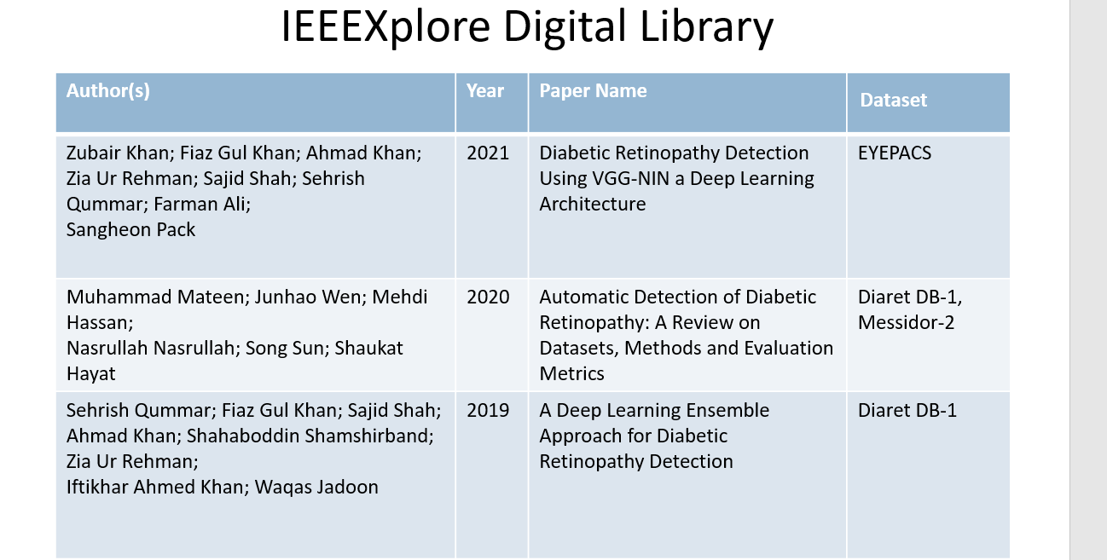Research on diabetic retinopathy has been extensively explored in various literature reviews. Despite the wealth of studies available on this topic, there appears to be a notable gap in research focusing on diabetic retinopathy within specific contexts. Our investigation revealed a dearth of studies addressing diabetic retinopathy using diverse data sources. This gap in the literature underscores the need for further research and exploration into diabetic retinopathy, potentially offering valuable insights into the prevalence, risk factors, and management strategies tailored to different demographics. Closing this gap through the use of a distributed machine learning system that trains on images in real-time could significantly enhance the accuracy and effectiveness of diabetic retinopathy detection and management.

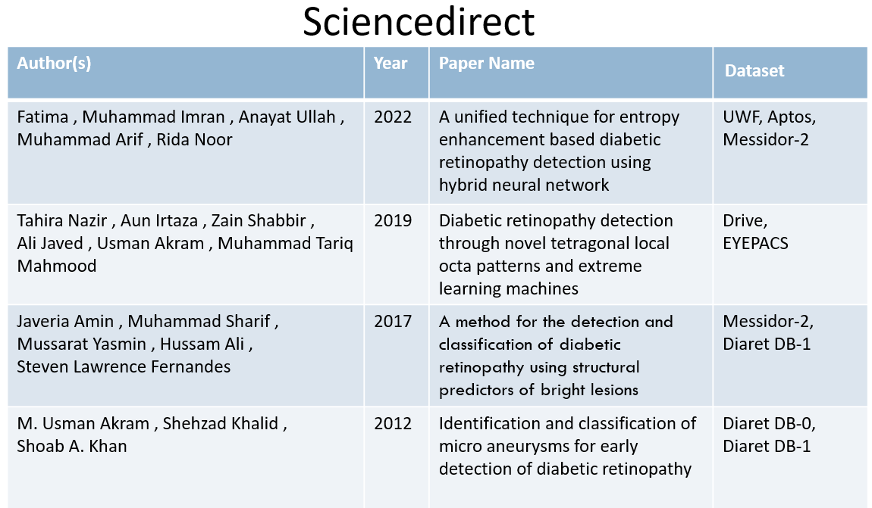

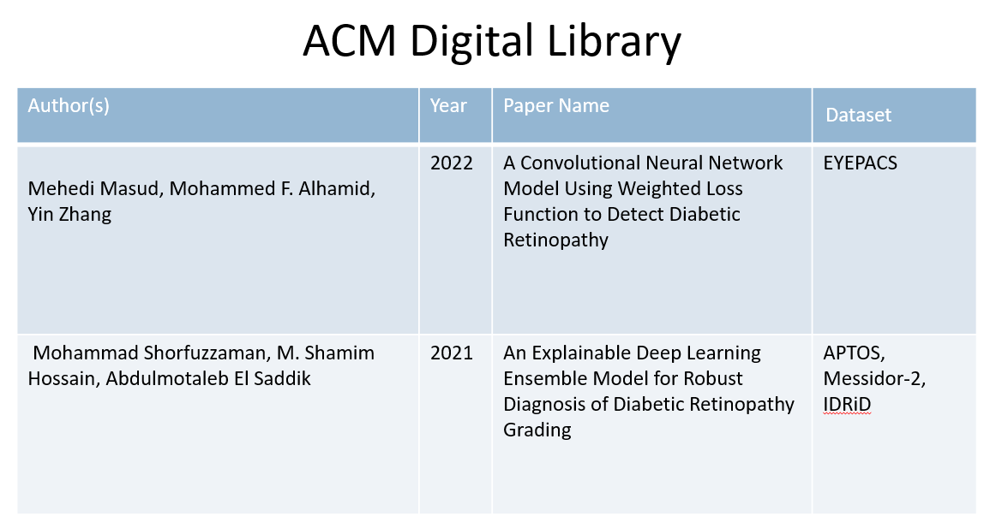

## 

# Project Functions

The web-based platform for the Automated Detection and Monitoring of Diabetic Retinopathy Using Artificial Intelligence (AI) is a sophisticated online application designed to facilitate the efficient diagnosis and ongoing assessment of diabetic retinopathy through advanced AI algorithms. This platform seamlessly integrates cutting-edge technology with user-friendly web interfaces, providing healthcare professionals with a powerful tool for enhancing patient care, the key functions of the project include**:**

1. **Diagnosis and Assessment:** The platform utilizes advanced AI algorithms to analyze retinal images at various stages, facilitating the detection and ongoing monitoring of diabetic retinopathy.
2. **Integration of Technology:** The system integrates state-of-the-art technology, ensuring the seamless operation of AI algorithms within existing healthcare frameworks.
3. **User-Friendly Interface:** The platform features an intuitive web interface designed for healthcare professionals. This interface enables easy uploading of retinal images, viewing of analysis results, and efficient interpretation of findings.
4. **Efficient Detection:** Leveraging AI, the system identifies early signs of diabetic retinopathy with a high degree of accuracy, aiding in timely intervention and treatment.

# Image Pre-Processing of DR

1. **Input Image:**

The process begins with the input of retinal images containing vital information for diabetic retinopathy detection.

1. **Transformation:**

The images undergo transformation, adjusting for factors like scale, rotation, or skewness to standardize the input for subsequent stages.

1. **Filtering:**

Filtering techniques are applied to enhance the clarity of retinal features, aiding in the identification of potential indicators of diabetic retinopathy.

1. **Data Augmentation:**

Data augmentation techniques are implemented to diversify the dataset, introducing variations such as changes in brightness, contrast, or orientation. This enhances the algorithm's ability to handle real-world variability.

1. **Segmentation:**

The preprocessed images then undergo segmentation, a critical step where advanced algorithms isolate specific regions of interest. This includes the segmentation of blood vessels, lesion detection, and identification of the optic disc and optic cup.

1. **Performance Evaluation:**

The segmented images are subject to thorough performance evaluation, involving both preprocessing and segmentation stages. This assessment ensures the accuracy and reliability of the algorithm in isolating relevant features.

1. **Result - Segmented Images:**

The output comprises segmented images showcasing distinct features: the first image highlights blood vessel segmentation, the second image illustrates lesion detection, and the third image depicts segmentation of the optic disc and optic cup. These segmented images serve as crucial inputs for subsequent analysis.

1. **Diabetic Retinopathy Detection:**

Building upon the segmented images, the final step involves diabetic retinopathy detection. The algorithm analyzes the isolated features, utilizing advanced AI techniques to identify signs of diabetic retinopathy, ultimately providing healthcare professionals with valuable insights for diagnosis and treatment planning

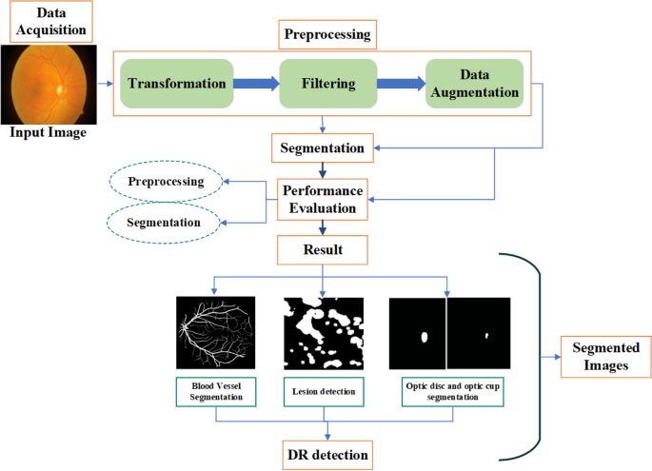*Figure 4: Image Pre-Processing of DR*

# Project Working

**Automated Reporting:** The platform automatically generates concise reports summarizing diagnostic findings and progression trends. These reports facilitate efficient communication of results to patients and collaboration among healthcare professionals.

* **Image Pre-processing:** Utilizing advanced deep learning algorithms, the system enhances diagnostic capabilities by processing retinal images to identify potential indicators of diabetic retinopathy.
* **Feature Engineering:** In this system, feature engineering refers to the process of carefully extracting and selecting pertinent information from retinal images. The aim is to enhance the accuracy of diabetic retinopathy detection by identifying and utilizing relevant features within the images.
* **User Interface:** The system is equipped with an intuitive web-based user interface tailored for medical professionals. This interface simplifies the process of uploading retinal images, allows easy viewing of analysis results, and facilitates efficient interpretation of findings. Its design prioritizes user-friendliness to enhance usability for healthcare practitioners.
* **Prediction:** A central component of the system is its prediction module, which utilizes analysis results to forecast the progression or severity of diabetic retinopathy. This feature provides valuable insights for treatment planning, assisting healthcare professionals in making informed decisions about patient care based on predicted outcomes.
* **Accuracy:** The algorithm development within the system places a high priority on achieving accuracy in diabetic retinopathy detection. The goal is to meet or exceed industry benchmarks, ensuring that the algorithm's performance in identifying signs of diabetic retinopathy is reliable and precise. Continuous assessment and refinement of the algorithm contribute to enhanced diagnostic reliability over time.

## User Classes and Characteristics

* **Ophthalmologists:** These are highly skilled users central to the diagnostic process. Ophthalmologists play a critical role in interpreting and validating the results generated by the AI algorithms. Their expertise is paramount in ensuring the accuracy and reliability of the diagnostic outcomes. Ophthalmologists contribute their extensive knowledge to the decision-making process, making them key stakeholders in the effective utilization of the system.
* **Technicians:** Technicians form another essential user class responsible for facilitating the system's operation. While they may not be directly involved in diagnostic decision-making, their role is pivotal in the preliminary stages. Technicians are primarily tasked with uploading retinal images to the system, serving as the crucial link between the raw data input and the subsequent diagnostic process. Their proficiency in handling image uploads contributes significantly to the overall efficiency of the system.

## Operating Environment

The system functions within a controlled medical environment, emphasizing proper lighting conditions and calibrated imaging devices. This carefully regulated setting ensures the accuracy and reliability of the analysis results, crucial for the system's effectiveness in diagnosing diabetic retinopathy.

## Design and Implementation Constraints

* Regulatory Compliance: The system strictly adheres to established medical regulations and standards, prioritizing patient safety and compliance with regulatory requirements.
* Technology Stack: Development is carried out using the Python programming language, leveraging a deep learning framework for image analysis. This technology stack ensures robust capabilities for accurate and efficient diabetic retinopathy detection.

## User Documentation

To support users in effectively utilizing the system, comprehensive user manuals and online help resources are provided. These resources aim to ensure a smooth and informed user experience, enabling healthcare professionals to navigate the system with confidence.

## Assumptions and Dependencies

Diabetic retinopathy's management relies on several assumptions and dependencies. These include accurate diabetes diagnosis, regular eye examinations, and the assumption of disease progression from mild to severe stages. Effective control of blood glucose levels and management of risk factors are essential. Additionally, access to healthcare services, patient compliance with treatment plans, and the efficacy of treatment modalities play crucial roles. Understanding these factors is pivotal for devising comprehensive strategies to prevent and manage diabetic retinopathy effectively.

• **Data Quality:**

* The system assumes the availability of a diverse and high-quality dataset for training the deep learning model. The quality of the training data is a critical factor influencing the performance of the AI algorithms.

• **Internet Connection:**

* The system's performance is dependent on a stable internet connection. This ensures seamless image uploads and efficient retrieval of analysis results, contributing to the overall functionality and user experience.

# External Interface Requirements

External Interface Requirements for a system or software refer to the interactions and connections it must have with external entities such as users, other systems, hardware, and networks. Here's an example of text outlining some external interface requirements:

## User Interfaces

The user interface is designed as a web-based platform, offering users a seamless experience. This interface allows for easy uploading of retinal images, provides a user-friendly environment for reviewing detailed results, and enables the downloading of comprehensive reports, enhancing the accessibility and utility of the system for healthcare professionals.

## Communications Interfaces

To ensure secure data transmission, the system will communicate over HTTPS protocols. This ensures the integrity and confidentiality of data exchanged between the user interface, AI modules, and the database.

# System Features

This section details the integral functionalities of the system, enhancing diabetic retinopathy diagnosis and management.

## Predictions of disease

The system's primary feature involves utilizing advanced deep learning algorithms to analyze retinal images. This process is designed to detect and classify potential signs of diabetic retinopathy, contributing to early and accurate diagnosis.

## Automated Screening

Utilizing machine learning models, the system automates the screening process for diabetic retinopathy. It efficiently triages retinal images, identifying cases requiring further review by healthcare professionals, thus optimizing resource allocation and reducing workload burden.

## Continuous Learning and Improvement

The system employs a feedback loop mechanism to continuously learn from new data and user interactions. By iteratively refining its algorithms and updating its knowledge base, it adapts to evolving clinical standards and enhances diagnostic accuracy over time.

## Use Case Diagram

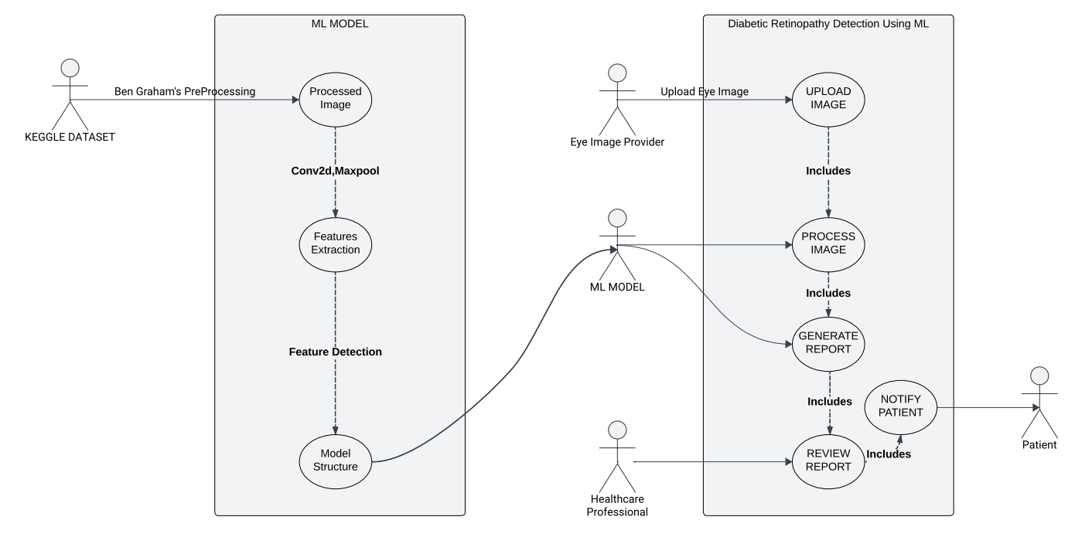

## Class Diagram

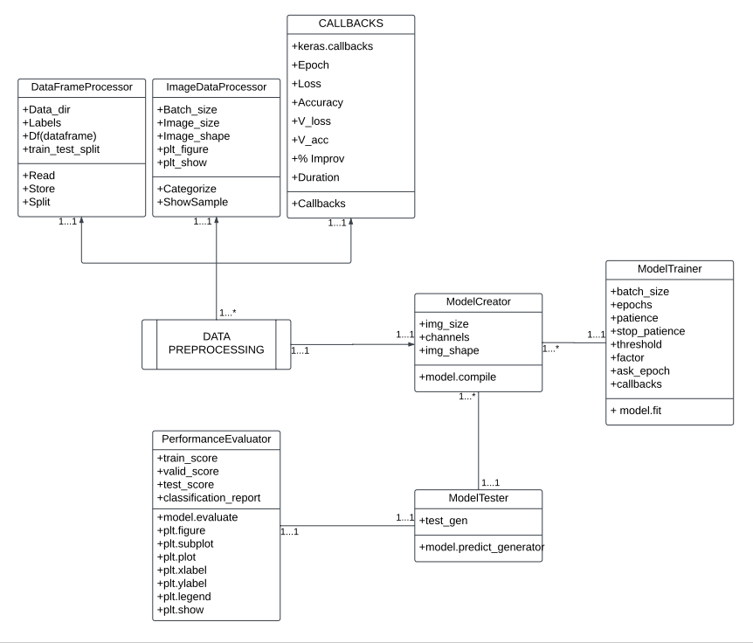

# Other Non-functional Requirements

This section outlines the non-functional requirements essential for the effective functioning and performance of the diabetic retinopathy diagnosis system.

## Performance Requirements

* The system must process retinal images within a maximum timeframe of 30 seconds to ensure timely diagnostic results.
* Concurrent access by multiple users should be supported, enhancing efficiency in a multi-user environment.

## Safety Requirements

* The system must adhere to established medical safety standards to guarantee patient safety during the diagnostic process.
* The system should not alter or damage input images, ensuring the integrity of the original data.

## Security Requirements

* User data and medical images must be stored and transmitted securely to maintain confidentiality and privacy.
* User access should be protected through robust authentication and authorization mechanisms.

## Software Quality Attributes

* The system's diabetic retinopathy detection accuracy should achieve a minimum rate of 75%.
* Scalability is a key attribute, ensuring the system can accommodate a growing database of retinal images.
* Reliability: The system should consistently provide accurate and dependable results.
* Maintainability: The system should be designed for easy updates, modifications, and maintenance.

## Usability Requirements:

* The user interface should be intuitive, requiring minimal training for healthcare professionals.
* The system should provide clear and easily understandable reports for effective communication of diagnostic findings.

# References

## Figure1:

https://www.ranueye.com/diabetic-retinopathy-dr-2/

## Figure2:

<https://www.drsnyder.org/eye-care-services/eye-disease-management/diabetic-retinopathy/the-4-stages-of-diabetic-retinopathy/>

## Figure3:

[https://www.researchgate.net/figure/Illustration-of-diabetic-retinopathy-symptoms-clinical-risk-factors-and-overall-  
workflow_fig1_372988862](https://www.researchgate.net/figure/Illustration-of-diabetic-retinopathy-symptoms-clinical-risk-factors-and-overall-workflow_fig1_372988862)

## Figure 4:

<https://link.springer.com/article/10.1007/s11831-022-098620#Fig3>

## ****IEEE Xplore Digital Library****

<https://ieeexplore.ieee.org/document/8869883>

<https://ieeexplore.ieee.org/document/9032162/>

<https://ieeexplore.ieee.org/document/9409084/>

## ****ACM Digital Library****

[https://dl.acm.org/doi/10.1145/3469841#pill-authors__contentcon](https://dl.acm.org/doi/10.1145/3469841)

<https://dl.acm.org/doi/10.1145/3470976>

## ****ScienceDirect****

<https://www.sciencedirect.com/science/article/abs/pii/S0933365718306584>

<https://www.sciencedirect.com/science/article/abs/pii/S0010482522002165>

<https://www.sciencedirect.com/science/article/abs/pii/S003132031200297X>

<https://www.sciencedirect.com/science/article/abs/pii/S1877750317300546>